**Design Thinking Project Workbook**

**Don't find customers for your product but find products for your customers**

**1. Team**

**Team Name: CODE BUILDER**

**Team Members:**

1. Manasa, Creating The Code Of Project, 2320030205
2. Rishika, interaction with clients, 2320030471
3. Gayathri, research of project in social platforms, 2320030382

**2. Problem/Opportunity Domain**

**Domain of Interest: AI-Assisted Code Generation**

**Description of the Domain:**

Code generation is a critical aspect of software development, enabling faster and more efficient coding processes. Traditional development requires manual coding, which can be time-consuming and prone to errors. AI-powered code generation leverages machine learning models like Gemini AI to analyze problem statements, input-output specifications, and expected results, automating the process of writing accurate and optimized code. This technology enhances productivity, reduces development costs, and supports multiple programming languages and frameworks.

**Why did you choose this domain?:**

* Personal interest in AI-driven automation and its impact on software development?
* High industry demand for intelligent coding assistants that improve efficiency and accuracy?

**3. Problem/Opportunity Statement**

**Problem Statement:**

Current weather forecasting systems often fail to provide hyper-local, real-time predictions with high accuracy, leading to inefficiencies and economic losses.

**Problem Description:**

Developers often struggle with writing code from scratch, debugging errors, and ensuring efficiency. Traditional development methods lack automation, making it difficult to quickly generate code that meets problem-specific constraints and expected outputs. AI-assisted solutions can streamline this process by analyzing problem statements and generating optimized code automatically.

**Context (When does the problem occur):**

* When developers need quick, accurate code solutions.
* During competitive programming, software prototyping, or automation tasks.

**Alternatives (What does the customer do to fix the problem):**

* Search for solutions online (Stack Overflow, GitHub, forums).
* Write and debug code manually.

**Customers (Who has the problem most often):**

Software developers, students, competitive programmers, businesses needing automation, and non-programmers looking for code solutions.

**Emotional Impact (How does the customer feel):**

* Frustrated by time-consuming coding and debugging.
* Overwhelmed when learning new programming languages or solving complex problems.

**Quantifiable Impact (What is the measurable impact):**

* Time savings due to automated code generation.
* Faster software development cycles and reduced debugging efforts.
* Increased accessibility for non-experts to generate functional code.

**Alternative Shortcomings (What are the disadvantages of the alternatives):**

* Manually searching for solutions can be inefficient and unreliable.
* Writing code from scratch increases development time and the likelihood of errors.

**Any Video or Images to showcase the problem:**

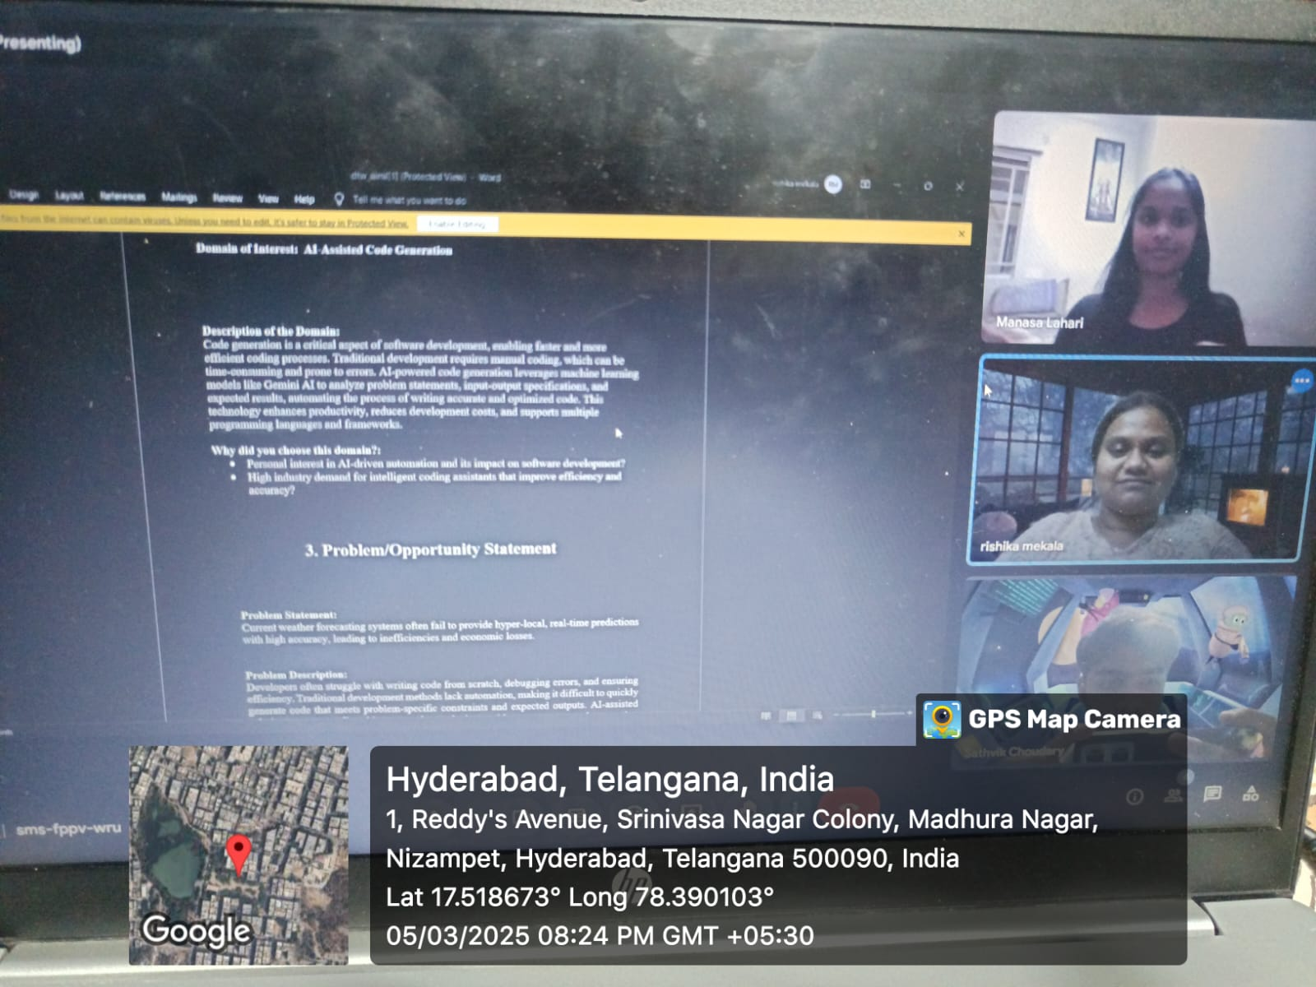

**3. Addressing SDGs**

**Relevant Sustainable Development Goals (SDGs):**

* SDG 4: Quality Education
* SDG 9: Industry, Innovation, and Infrastructure

**How does your problem/opportunity address these SDGs?:**

* SDG 4 (Quality Education): Code Builder democratizes access to programming by enabling students and beginners to learn and generate code efficiently, reducing the barrier to entry in software development.
* SDG 9 (Industry, Innovation, and Infrastructure): AI-driven code generation fosters innovation by streamlining software development, improving productivity, and accelerating technological advancements in various industries.

**4. Stakeholders**

Answer these below questions to understand the stakeholder related to your project

1. **Who are the key stakeholders involved in or affected by this project?**

Software developers, students, educators, tech companies, startups, and AI researchers.

1. **What roles do the stakeholders play in the success of the innovation?**

Developers and students use the platform, companies integrate it, startups benefit from automation, and researchers enhance AI capabilities.

1. **What are the main interests and concerns of each stakeholder?**

Industries Developers need accurate code, companies seek efficiency, startups want fast development, and researchers focus on AI advancements.

1. **How much influence does each stakeholder have on the outcome of the project?**

Developers, companies, and researchers have high influence, while students and educators have moderate influence.

1. **What is the level of engagement or support expected from each stakeholder?**

High High engagement from developers, students, and researchers, with moderate involvement from companies and startups.

1. **How will you communicate and collaborate with stakeholders throughout the project?**

Through online forums, GitHub, social media, open-source contributions, feedback loops, and research partnerships.

**5. Power Interest Matrix of Stakeholders**

**Power Interest Matrix:**

**High Power, High Interest: Meteorological agencies, AI researchers High Power, Low Interest: Government authorities Low Power, High Interest: Farmers, logistics compnies, consumers Low Power, Low Interest: General public**

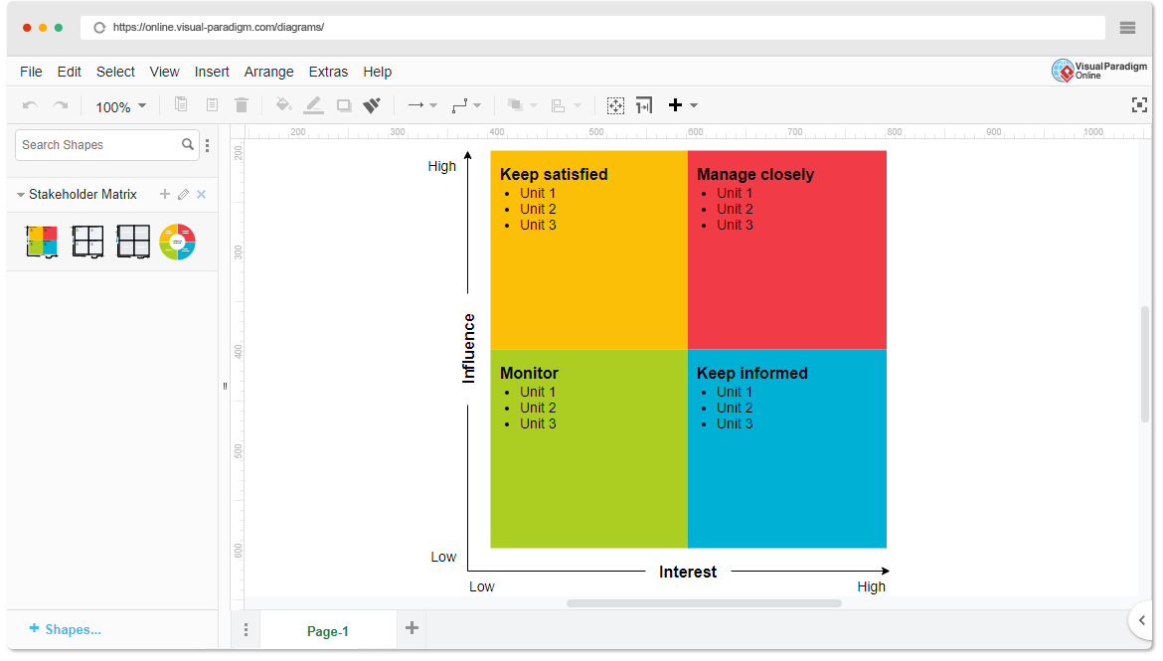

* **High Power, High Interest:** Tech companies, AI researchers
* **High Power, Low Interest:** Regulatory bodies, educational institutions
* **Low Power, High Interest:** Developers, students, startups
* **Low Power, Low Interest:** General public

1. **Empathetic Interviews**

**Conduct Skilled interview with at least 30 citizens/Users by asking open ended questions (What, why/How etc) and list the insights as per the format below**

|  |  |  |
| --- | --- | --- |
| **I need to know**  **(thoughts, feelings, actions)** | **Questions I will ask**  **(open questions)** | **Insights I hope to gain** |
| Thoughts | What are your key expectations from an AI-powered code generation tool? | Understand what users seek in automated coding solutions. |
| How accurate and reliable is the AI model? | How accurate and reliable should AI-generated code be? | Identify key success indicators for AI-driven code generation. |
| Will this project provide a competitive edge? | Will this tool provide a competitive advantage in software development? | Learn if AI-generated code can improve efficiency and productivity. |
| Feelings | How confident are you in AI-generated code? | Assess trust levels and skepticism among developers. |
| Enthusiastic but cautious about AI's potential | What concerns do you have about AI automating coding tasks? | Identify fears related to job displacement or code reliability. |
| Motivated to ensure project success | How would an AI coding assistant impact your workflow? | Understand how users perceive AI in their daily coding tasks. |
| actions | What programming languages and frameworks should the tool support? | Gather insights on preferred languages and tools. |
| Actively participate in decision-making | How would you like to interact with the AI tool? | Identify user preferences for UI/UX and integration. |
| Provide funding, resources, and strategic direction | What concerns do you have regarding data security and privacy? | Address ethical considerations and trust factors. |

**SKILLED INTERVIEW REPORT**

**(Examples are given. Erase them and fill with your user information.)**

|  |  |  |
| --- | --- | --- |
| **User/Interviewee** | **Questions Asked** | **Insights gained (NOT THEIR ANSWERS)** |
| Sathvik, Computer Science Student | What are your key expectations from an AI-powered code generator? | Students want AI-generated code to be explainable and beginner-friendly. |
| Manaswi, Software Developer | How do you currently handle complex coding tasks? | Developers spend a lot of time debugging and optimizing code manually. |
| Karthik, AI Researcher | How confident are you in AI-generated code? | AI researchers believe AI can assist but should not replace human oversight. |
| Rohit, Startup Founder | What features would make this tool indispensable for your work? | Startups seek AI-generated code that integrates seamlessly with their existing tech stacks. |
| Deepthi, Educator | |  | | --- | |  |  |  | | --- | | How would an AI assistant impact your learning process? | | **Educators want AI tools to enhance, not replace, traditional programming education.** |

**Empathy Map**

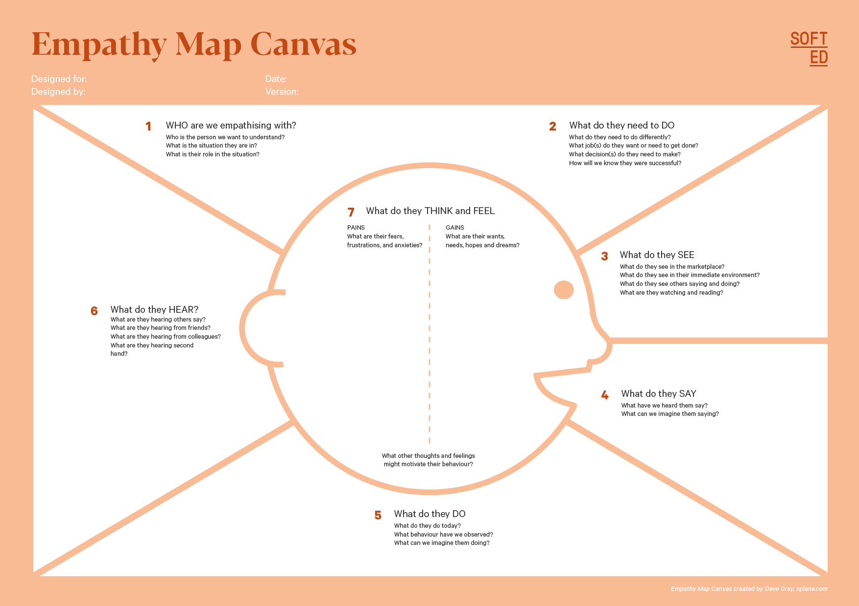

Your Answer:

Your Answer:

Who is your Customer Segment:

Idea/Innovation Title:

Designed By:

Date of Submission:

Your Answer:

Your Answer:

Your Answer:

Your Answer:

Your Answer:

Your Answer:

Your Answer:

1. **Empathy Map**
2. **Who is your Customer?**

**Description: sravani**

**Key points:**

* 45 years old, government employee, interested in AI-powered automation.
* Wants an AI-based coding assistant to simplify software development.

1. **Who are we empathizing with?**

Users seeking AI-generated code to improve efficiency and accuracy in software development.

**Key points:**

* The client is innovative, polite, and eager to explore AI-driven solutions.
* Aims to make software development more accessible, efficient, and error-free.

**8. Persona of Stakeholders**

**Stakeholder Name: sravani**

**Demographics:**

* 45 years old, urban area, works in the government sector.
* Interested in AI-driven automation for software development.

**Goals:**

* Simplify coding for beginners and professionals.
* Improve software development efficiency and reduce errors.
* Enable faster prototyping and problem-solving using AI-generated code.

**Challenges:**

* Manual coding is time-consuming and prone to errors.
* Difficulty in learning and adapting to new programming languages.
* Lack of accessible AI tools for non-experts.

**Aspiration:**

* Enhance productivity by automating code generation.
* Make AI-assisted coding accessible to students, developers, and enterprises.

**Needs:**

* AI-generated, optimized, and error-free code in multiple languages.
* A user-friendly interface for seamless integration into development workflows.

**Pain Points:**

* Time wasted in debugging and searching for coding solutions.
* Inconsistent coding standards and efficiency in manual development.

**Sample:**

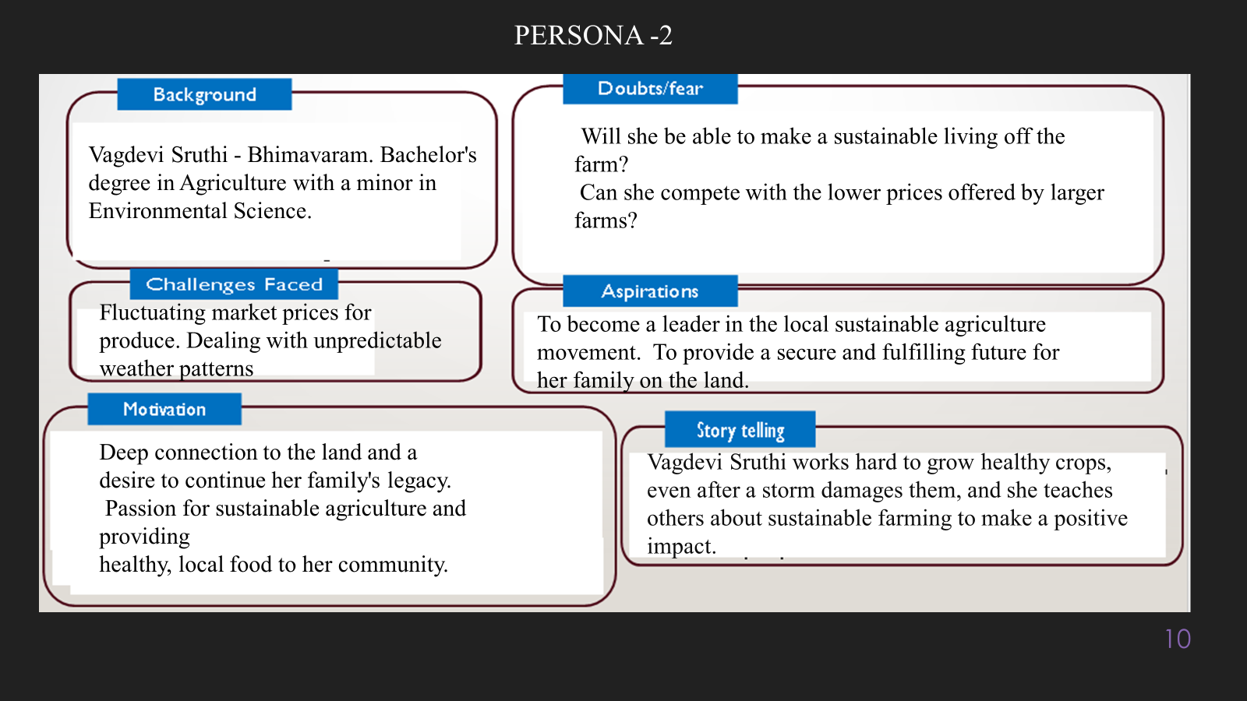

**10. Look for Common Themes, Behaviors, Needs, and Pain Points among the Users**

Analyse the data from your affinity diagram to uncover recurring patterns among your users, helping you better understand their expectations and challenges.

**Common Themes:**

* Users struggle with writing efficient and error-free code.
* Many developers rely on online forums for coding solutions.
* AI-powered automation is seen as a way to improve productivity

**Common Behaviors:**

* Users search for existing code snippets instead of writing from scratch.
* Developers prefer tools that integrate seamlessly with their workflows.
* Beginners look for AI-assisted learning and debugging support.

**Common Needs:**

* A user-friendly AI-powered code generator.
* Support for multiple programming languages and frameworks.
* Accurate, efficient, and well-documented code output.

**Common Pain Points:**

* Time-consuming debugging and troubleshooting.
* Lack of trust in AI-generated code accuracy.
* Difficulty in learning new programming concepts without guidance.

**12. Define Needs and Insights of Your Users**

**User Needs:**

* Accurate and Efficient Code Generation – Users need AI-generated code that is optimized, error-free, and reliable.
* Support for Multiple Programming Languages – The tool should generate code for various languages based on user requirements.
* User-Friendly Interface – A simple and intuitive platform that allows easy input of problem statements and clear output of generated code.

**User Insights:**

* Decision-Making is Code-Dependent – Users rely on AI-generated code for debugging, learning, and accelerating development.
* Concerns About Code Accuracy – Developers often verify AI-generated code with external sources before using it.
* High Demand for Customization – Users want AI-generated code to be adaptable to their specific needs and coding styles.

**13. POV Statements**

**POV Statements:**

|  |  |  |  |
| --- | --- | --- | --- |
| PoV Statements  (At least ten) | Role-based or Situation-Based | Benefit, Way to Benefit,  Job TBD,  Need (more/less) | PoV Questions  (At least one per statement) |
| A student learning programming who struggles with writing complex algorithms needs an AI-powered code generator because they require guidance and optimized solutions. | **A student learning programming** | **Faster learning and better problem-solving through AI-generated solutions.**. | How might we make AI-generated code more educational and explainable for beginners? |
| A software developer who spends hours debugging code needs an AI-assisted tool because automated debugging can save time and reduce frustration. | **A software developer** | **Faster debugging with AI-generated suggestions and explanations.** | Faster debugging with AI-generated suggestions and explanations. |
| A startup founder who rapidly builds MVPs needs an AI-powered coding assistant because manual coding slows down product development. | **A startup founder** | **Faster prototyping and reduced development time.** | How might we tailor AI-generated code to meet different business use cases efficiently? |
| A competitive programmer who participates in coding contests needs an AI-driven problem-solving tool because speed and accuracy are crucial. | **A competitive programmer** | **Quick AI-generated solutions for complex problem statements.** | How might we ensure AI-generated solutions align with competitive programming rules? |
| A freelancer who works on multiple tech stacks needs an AI-driven assistant because switching between languages and frameworks is time-consuming. | **A freelancer** | **Increased productivity through multi-language support and code suggestions.** | How might we make AI-generated code adaptable to various frameworks and libraries? |
| A non-technical entrepreneur who wants to build an app needs an AI tool because they lack programming expertise. | **A non-technical entrepreneur** | AI-generated templates for quick software development. | AI-generated templates for quick software development. |
| A project manager who oversees development teams needs an AI-powered coding tool because it can improve efficiency and collaboration. | **A project manage** | AI-assisted documentation and structured code generation. | How might we integrate AI-generated code into team-based development workflows? |
| A tech educator who teaches coding needs an AI-assisted tool because students struggle with syntax and logic. | **A tech educator** | AI-generated code with explanations for better learning | How might we design an AI-powered tool that enhances programming education? |

**14. Develop POV/How Might We (HMW) Questions to Transform Insights/Needs into Opportunities for Design**

|  |  |
| --- | --- |
| User Need/Insight | "How Might We" Question |
| Users need an AI tool that generates accurate, efficient, and bug-free code. | **How might we ensure AI-generated code is optimized, error-free, and meets industry standards?** |

**16. Crafting a Balanced and Actionable Design Challenge**

Develop an AI-powered code generation system that produces accurate, efficient, and customizable code based on user requirements, improving productivity for developers, students, and businesses.

**17. Validating the Problem Statement with Stakeholders for Alignment**

**Validation Plan:**

Engage stakeholders through meetings, surveys, and prototype demos to confirm the relevance and impact of the AI-powered code generator. Key questions assess usability, accuracy, and integration with existing workflows. Continuous feedback loops refine the system to align with developers, businesses, and educational institutions.

|  |  |  |  |
| --- | --- | --- | --- |
| Stakeholder/User | Role | Feedback on Problem Statement | Suggestions for Improvement |
| Software Developers |  | **Ensure AI-generated code is reliable, efficient, and bug-free.** | **Improve debugging and optimization features for better adoption.** |
| Students & Educators |  | **The tool should help beginners understand AI-generated code.** | **Include explanations and learning modules alongside generated code.** |

**18. Ideation**

**Ideation Process:**

|  |  |  |  |
| --- | --- | --- | --- |
| Idea Number | Proposed Solution | Key Features/Benefits | Challenges/Concerns |
| Idea 1 | |  | | --- | |  |  |  | | --- | | **AI-Driven Code Generation** | | **Generates optimized, error-free code for multiple language** | **Ensuring accuracy and best practices in AI-generated code.** |
| Idea 2 | **Real-Time Code Debugging** | **AI-assisted bug detection and fixes for faster development.** | **Handling complex debugging scenarios and maintaining efficiency.** |
| Idea 3 | **Personalized Code Suggestions** | **Adapts to user coding style and preferences.** | **Balancing customization with general usability.** |
| Idea 4 | **AI-Powered Code Explanation** | **Breaks down AI-generated code for better understanding.** | **Ensuring explanations are clear, concise, and educational.** |
| Idea 5 | **Multi-Language & Framework Support** | **Supports various programming languages and frameworks.** | **Managing compatibility and continuous updates for new technologies.** |

**Solution Concept Form**

**1. Problem Statement:**

Traditional software development is time-consuming, error-prone, and requires manual coding efforts.

**2. Target Audience:**

Software developers, students, educators, startups, businesses, and AI researchers.

**3. Solution Overview:**

AI-driven code generation system using machine learning to analyze problem statements and generate optimized code**.**

**4. Key Features:**

| **Feature** | **Description** |
| --- | --- |
| **Feature 1** | **AI-based code generation with high accuracy.** |
| **Feature 2** | **Support for multiple programming languages and frameworks.** |
| **Feature 3** | **Real-time debugging and optimization assistance.** |

**5. Benefits:**

| **Benefit** | **Description** |
| --- | --- |
| **Benefit 1** | **Faster software development with AI-generated code.** |
| **Benefit 2** | **Reduced debugging and troubleshooting time.** |
| **Benefit 3** | **Accessibility for beginners and non-technical users.** |

**6. Unique Value Proposition (UVP):**

AI-powered, real-time code generation that simplifies development, accelerates learning, and improves efficiency.

**7. Key Metrics:**

Code accuracy, execution efficiency, response time, and user adoption rate.

**8. Feasibility Assessment:**

Availability of AI models, datasets, and cloud computing infrastructure for efficient processing.

**9. Next Steps:**

Develop AI models, test with developers, integrate into IDEs, and launch a beta version.